Online diploma intro

Every Sunday (Weekly progress)
- Lecture
- Practical Session
- Assignment project
- Online Quizzes: Usually all the solutions of these quizzes are in the practical sessions
- Summery and Conclusions

Monitor you Progress
- GIT HUB Account
- Google Drive with 2 sheets
First Sheet: Quizzes
Quiz number | Quiz Topic | Scores

Second Sheet: Exams
Exam | Exam Topic | Scores

Lecture 1: Introduction

OS applications vs Bare metal

OS applications

Autosar Layered Architecture

Hypervisors
- Can run multiple operating system on the same SOC
- It’s also knowing as a VMM (virtual machine monitor) it’s a software that can mange two operating systems.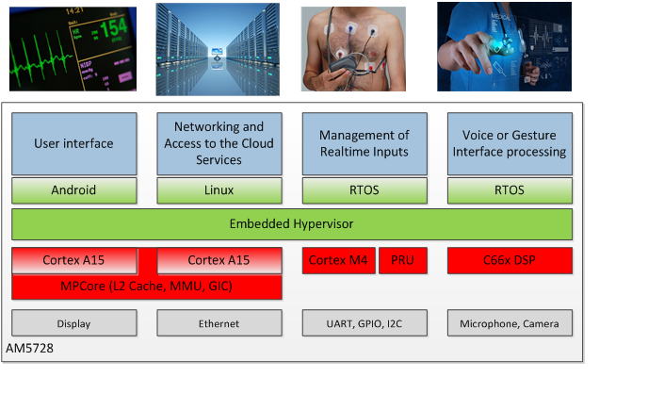

Learn Embedded Linux
Integration and device driver, Application
- Embedded system concepts
- Good knowledge Linux admiration
- Study embedded Linux basics
- Yocto project
- Embedded Linux device drivers

Wireless embedded system

Virtual Verification and Validation (The triple Vs)

ADAS (Advanced Driver Assistance system)

Lecture 2: Version Control Systems (GIT)

Basics
Git Commands | Comments
Git init
Git config core.bare true
Git config –global user.name “Kirolos Magdy”
Git config –global user.email “Kmagdy.e97@gmail.com”
Git status
Git log
Gitk
git clone kmagdiii/MasteringEmbeddedSystem_Online: This repo is for embedded diploma for embedded systems programming (github.com)
Git clone f:\repo01
Git add readme.txt
Git add \myfile
Git remove head readme.txt
Git add * | Adds all the file in the dir
Git commit -m “fixed 7231 bug”
Git branch
Git remote -v
Git pull origin master
Git config -l | Lists all the configuration data and its values
Git config –global user.name “Kirolos”
Git config –global user.email “kmagdy@gmail.com”
git config -l --show-origin | Shows each data file path
git config --global --unset user.email | Used to unset configuration value
Git config –global –edit

Branch management
Git Command | Comment
Git checkout -b pointes | Creating new branch named pointers
git push --set-upstream origin CArrayAndStrings | Creating a new branch in the remote repo to push the local branch
Git Diff master branch_ | Shows difference between the master branch an any other branch
Git branch -d <branch> | Delete a branch from the repo
Git branch | Show the local branches
Git branch --all

Unit 2: Lecture 2 C basics
- The difference between development and cross development
- Tool chain (Native/Cross)
- MinGW : Native tool chain

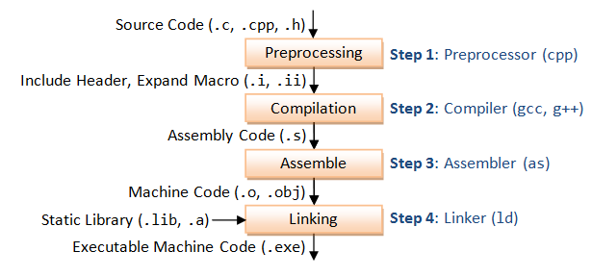
- variable name; address; value
- Implicit and explicit type conversion
- Bit wise operations
- Postfix and prefix
- Conditions
- In line conditions
- For loops
- Switch case
- Do while loop
- While loop
- Break, continue and goto keywords
- Nested for loop example

